ClinicOS

A Web-Based Clinic Management System for Personal Clinics

Software Requirements Specification (SRS)
Prepared By: Group-8
Student ID | Student Name
23201356 | Abdullah Al Noman
24121287 | Partho Probal
23301144 | Rifat Abdullah Sarker
23201673 | Md. Shafinuzzaman

Table of Contents
1. Introduction
1.1 Purpose
1.2 Scope
1.3 Definitions, Acronyms and Abbreviations
1.4 References
1.5 Overview
2. Overall Description
2.1 Product Perspective
2.2 Product Features
2.3 User Classes and Characteristics
2.4 Operating Environment
2.5 Design Constraints
2.6 Assumptions and Dependencies
3. System Requirements
3.1 Functional Requirements
- Authentication & User Management
- Clinic & Doctor Management
- Patient Management
- Appointment Management
- Electronic Medical Records
- Prescription Management
- Payment & Billing
- Notifications & Communication
- Reviews & Feedback
- Subscription Management
3.2 Non-Functional Requirements
3.3 External Interface Requirements
4. Technology Stack & System Architecture
4.1 MERN Stack Components
4.2 High-Level System Architecture
4.3 Database Overview
5. Development Plan (Agile Methodology)
6. Acceptance Criteria
7. Conclusion

1. Introduction

1.1 Purpose
This Software Requirements Specification (SRS) defines the functional and non-functional requirements for ClinicOS, a digital clinic management platform developed using the MERN stack (MongoDB, Express.js, React.js, and Node.js).
The primary objective of ClinicOS is to provide independent doctors and private healthcare clinics with an affordable and centralized platform for managing daily clinical operations. The system enables doctors to establish digital clinics, manage appointments, maintain electronic medical records, generate digital prescriptions, process payments, and communicate efficiently with patients.
This document serves as a reference for developers, testers, project supervisors, and stakeholders throughout the software development life cycle. It establishes a clear understanding of the system's expected behavior and quality requirements before implementation begins.

1.2 Scope
ClinicOS is designed primarily for independent medical practitioners and small to medium-sized healthcare clinics. Unlike traditional Hospital Management Systems (HMS), which are intended for large hospitals with multiple departments, ClinicOS focuses on simplifying clinic operations through a cloud-based SaaS platform.
The system provides role-based access for four primary user groups:
- Patients
- Doctors (Clinic Owners)
- Clinic Assistants
- Platform Administrators
The platform allows doctors to create and manage one or more digital clinics, define consultation services, schedule appointments, maintain patient records, generate electronic prescriptions, and monitor clinic performance. Patients can discover clinics, book appointments, access prescriptions, view medical history, and securely manage online payments through a unified portal.
The project also supports future enhancements such as telemedicine, AI-assisted healthcare services, mobile applications, and advanced analytics.

1.3 Definitions, Acronyms, and Abbreviations
Term | Definition
API | Application Programming Interface
CRUD | Create, Read, Update, Delete
EMR | Electronic Medical Record
JWT | JSON Web Token
MERN | MongoDB, Express.js, React.js, Node.js
NoSQL | Non-relational database management system
OTP | One-Time Password
RBAC | Role-Based Access Control
REST | Representational State Transfer
SaaS | Software as a Service
UI | User Interface
UX | User Experience

1.4 References
The following resources were used during the preparation of this Software Requirements Specification:
- IEEE Recommended Practice for Software Requirements Specifications (IEEE 830)
- ISO/IEC/IEEE 29148:2018 Systems and Software Engineering – Requirements Engineering
- MongoDB Documentation
- Express.js Documentation
- React Documentation
- Node.js Documentation
- Bootstrap Documentation
- REST API Design Guidelines

1.5 Overview
This Software Requirements Specification is organized into seven major sections.
Section 1 introduces the purpose, scope, terminology, references, and organization of the document.
Section 2 presents an overall description of ClinicOS, including its product perspective, major features, intended users, operating environment, design constraints, and project assumptions.
Section 3 specifies the functional and non-functional requirements, along with the external interfaces required for the successful operation of the system.
Section 4 describes the proposed technology stack and the overall system architecture, providing a high-level overview of the application's design and implementation approach.
Section 5 outlines the tentative Agile development plan and sprint-wise implementation strategy.
Section 6 defines the acceptance criteria used to verify that the system satisfies the specified requirements.
Finally, Section 7 concludes the document by summarizing the objectives and expected outcomes of the ClinicOS platform.

2. Overall Description

2.1 Product Perspective
ClinicOS is a cloud-based platform developed to help independent doctors and private healthcare clinics establish and manage their own digital clinics. Unlike traditional Hospital Management Systems (HMS), which are designed for large hospitals with multiple departments, ClinicOS focuses on the operational needs of individual practitioners and small to medium-sized clinics.
The platform serves as a centralized digital ecosystem where doctors can manage appointments, maintain electronic medical records, generate digital prescriptions, monitor clinic activities, and communicate with patients through a single web application.
ClinicOS follows a multi-tenant SaaS architecture, allowing multiple clinics to operate independently on the same platform while ensuring complete isolation of each clinic's data. Every clinic maintains its own patients, appointments, staff, consultation services, and business information.
Patients can search for clinics and doctors, schedule appointments, access prescriptions and medical records, make online payments, and communicate with healthcare providers through a unified patient portal.
The system is intended to replace traditional paper-based clinic management with a secure, scalable, and affordable digital solution.

2.2 Product Features
ClinicOS provides a comprehensive set of features to support both clinical and administrative operations.

Authentication & User Management
- User Registration
- Secure Login
- Password Recovery
- Email Verification
- Role-Based Access Control (RBAC)

Clinic & Doctor Management
- Clinic Creation and Management
- Doctor Profile Management
- Consultation Scheduling
- Clinic Branding
- Service Management

Patient Management
- Patient Registration
- Patient Profile Management
- Medical History
- Treatment History

Appointment Management
- Online Appointment Booking
- Appointment Confirmation
- Appointment Rescheduling
- Appointment Cancellation
- Appointment History

Medical Services
- Electronic Medical Records (EMR)
- Digital Prescription Generation
- Medical Report Management
- Treatment Tracking

Communication
- Email Notifications
- Appointment Reminders
- Secure Messaging
- Video Consultation (Future Enhancement)

Payment & Billing
- Online Payment Processing
- Transaction History
- Invoice Generation
- Revenue Tracking

Reviews & Feedback
- Doctor Ratings
- Clinic Reviews
- Patient Feedback

SaaS Management
- Subscription Plans
- Subscription Renewal
- Clinic Administration
- Platform Analytics

2.3 User Classes and Characteristics
The ClinicOS platform supports four primary user classes.

Patient
Patients are registered users who receive healthcare services from clinics available on the platform.
Patients can:
- Register and manage their accounts
- Search clinics and doctors
- Book appointments
- View prescriptions
- Access medical history
- Make online payments
- Leave reviews and ratings
Patients have read-only access to their medical records and cannot modify clinical information.

Doctor (Clinic Owner)
Doctors are the primary customers of the platform and are responsible for managing their digital clinics.
Doctors can:
- Create and manage clinics
- Manage consultation schedules
- Maintain patient records
- Generate digital prescriptions
- View appointment schedules
- Monitor clinic performance
- Manage clinic assistants

Clinic Assistant
Clinic Assistants support doctors in managing daily clinic operations.
Assistants can:
- Register patients
- Manage appointments
- Update patient information
- Upload medical reports
- Assist with administrative tasks
Assistants have limited permissions and cannot modify clinic ownership or subscription settings.

Platform Administrator
Platform Administrators manage the overall ClinicOS platform.
Administrators can:
- Manage users
- Monitor clinics
- Manage subscription plans
- View platform analytics
- Moderate reviews
- Maintain system performance
Administrators do not participate in patient treatment or access confidential medical information unless authorized.

2.4 Operating Environment
ClinicOS is designed as a cloud-based web application that can be accessed from various devices and operating systems.

Client Environment
- Google Chrome
- Mozilla Firefox
- Microsoft Edge
- Safari

Supported Devices
- Desktop Computers
- Laptop Computers
- Tablets
- Smartphones

Server Environment
- Node.js Runtime
- Express.js Server
- Docker Containers (Optional)
- Nginx Reverse Proxy

Database
- MongoDB Atlas (Cloud Database)

Internet Requirements
Users require a stable internet connection to access cloud-hosted services and perform online activities such as appointment booking, payment processing, and medical record management.

2.5 Design Constraints
The development of ClinicOS is subject to the following constraints:
- The application shall be developed using the MERN Stack.
- The system shall operate as a web-based SaaS platform.
- Patient data shall remain isolated between different clinics.
- Medical records shall only be accessible by authorized users.
- All communication shall be secured using HTTPS.
- User passwords shall be encrypted before storage.
- The system shall provide responsive interfaces for desktop and mobile devices.
- The platform shall support future expansion without major architectural changes.

2.6 Assumptions and Dependencies
The following assumptions have been made during the planning and development of ClinicOS.

Assumptions
- Users have access to a stable internet connection.
- Doctors possess valid professional credentials.
- Patients provide accurate personal information.
- Clinic staff have basic computer literacy.
- Cloud infrastructure remains available throughout system operation.

Dependencies
ClinicOS depends on several external services for complete functionality.
- MongoDB Atlas (Cloud Database)
- Email Service Provider (SMTP/Nodemailer)
- Payment Gateway (Stripe or SSLCommerz)
- Cloud Storage Service (Cloudinary or AWS S3)
- Google Maps API
- Video Consultation Service (Future Integration)
Failure of these third-party services may temporarily affect specific platform functionalities while the core application remains operational.

3. System Requirements

3.1 Functional Requirements
The following functional requirements define the expected behavior and capabilities of ClinicOS. The system shall provide these features to ensure efficient clinic management, secure healthcare services, and an enhanced user experience.

3.1.1 Authentication & User Management

Description
The system shall provide secure user authentication and authorization while ensuring that users can only access features permitted by their assigned roles.

Functional Requirements
FR-1: The system shall allow patients and doctors to register using their personal information.
FR-2: The system shall verify that every registered email address is unique.
FR-3: The system shall encrypt user passwords before storing them in the database.
FR-4: The system shall verify user email addresses before allowing login.
FR-5: Registered users shall be able to log in using their email address and password.
FR-6: Users shall be able to recover forgotten passwords through email verification.
FR-7: The system shall implement Role-Based Access Control (RBAC) for Patients, Doctors, Clinic Assistants, and Platform Administrators.
FR-8: The system shall redirect authenticated users to role-specific dashboards after successful login.

3.1.2 Clinic & Doctor Management

Description
Clinic Owners shall be able to establish and manage digital clinics while maintaining professional profiles and consultation information.

Functional Requirements
FR-9: Doctors shall be able to create and manage one or more clinics.
FR-10: Doctors shall maintain professional profiles including qualifications, specialization, experience, and consultation fees.
FR-11: Doctors shall define clinic operating hours and consultation schedules.
FR-12: Doctors shall create and manage medical services offered by their clinics.
FR-13: Doctors shall create, modify, or remove consultation packages.
FR-14: Doctors shall upload clinic branding elements such as logos and banners.

3.1.3 Patient Management

Description
The system shall enable patients to maintain personal information and access healthcare services efficiently.

Functional Requirements
FR-15: Patients shall be able to create and update their profiles.
FR-16: Patients shall search clinics by name, location, or specialization.
FR-17: Patients shall search doctors based on specialty and availability.
FR-18: Patients shall access their consultation history and treatment records.
FR-19: Patients shall securely view their personal medical information.

3.1.4 Appointment Management

Description
The system shall provide an efficient online appointment scheduling system for both patients and doctors.

Functional Requirements
FR-20: Patients shall book appointments through the platform.
FR-21: Patients shall reschedule or cancel appointments before the scheduled consultation time.
FR-22: Doctors shall view and manage appointment schedules.
FR-23: The system shall notify users about appointment confirmations, cancellations, and reminders.
FR-24: The system shall maintain appointment history for future reference.

3.1.5 Electronic Medical Records (EMR)

Description
The system shall securely maintain patients' medical information in digital form.

Functional Requirements
FR-25: Doctors shall create and update electronic medical records.
FR-26: Medical records shall include diagnoses, symptoms, treatments, and follow-up recommendations.
FR-27: Authorized users shall securely access patient medical records.
FR-28: The system shall maintain complete medical history for every patient.

3.1.6 Prescription Management

Description
Doctors shall generate and manage digital prescriptions electronically.

Functional Requirements
FR-29: Doctors shall generate digital prescriptions after consultations.
FR-30: Patients shall download and view their prescriptions through the patient portal.
FR-31: The system shall maintain prescription history for future reference.

3.1.7 Payment & Billing

Description
The system shall support secure online payment processing and billing management.

Functional Requirements
FR-32: Patients shall make secure online payments for appointments.
FR-33: The system shall generate invoices after successful payments.
FR-34: Doctors shall view clinic revenue and payment history.

3.1.8 Notifications & Communication

Description
The platform shall facilitate communication between users through notifications and messaging services.

Functional Requirements
FR-35: The system shall send email notifications for appointments and account activities.
FR-36: Patients and doctors shall exchange secure messages through the platform.
FR-37: The system shall support online video consultations in future versions.

3.1.9 Reviews & Feedback

Description
Patients shall provide feedback regarding healthcare services received through the platform.

Functional Requirements
FR-38: Patients shall rate doctors and clinics after consultations.
FR-39: Doctors shall view patient reviews and ratings.

3.1.10 SaaS Subscription Management

Description
The platform shall manage subscription plans for clinic owners.

Functional Requirements
FR-40: Doctors shall subscribe to available service plans.
FR-41: The system shall manage subscription renewals and expiration dates.
FR-42: Platform Administrators shall create and manage subscription plans.
FR-43: The system shall restrict premium features according to the subscribed plan.

3.2 Non-Functional Requirements
The following non-functional requirements define the quality attributes and operational characteristics that ClinicOS shall satisfy to ensure reliability, security, performance, and maintainability.

3.2.1 Performance Requirements
NFR-1: The system shall support multiple concurrent users without significant performance degradation.
NFR-2: Average page response time shall not exceed 3 seconds under normal operating conditions.
NFR-3: Appointment booking, prescription generation, and payment processing shall be completed with minimal delay.
NFR-4: The system shall efficiently manage increasing numbers of clinics, patients, and appointments without affecting overall performance.

3.2.2 Security Requirements
NFR-5: All communication between clients and the server shall use HTTPS with SSL/TLS encryption.
NFR-6: User passwords shall be securely hashed before being stored in the database.
NFR-7: The system shall implement Role-Based Access Control (RBAC) to prevent unauthorized access.
NFR-8: Only authorized healthcare professionals shall access patient medical records.
NFR-9: User sessions shall automatically expire after a period of inactivity.

3.2.3 Reliability & Availability
NFR-10: The platform shall maintain at least 99.9% availability, excluding scheduled maintenance.
NFR-11: Regular database backups shall be performed to minimize data loss.
NFR-12: The system shall recover gracefully from unexpected failures whenever possible.

3.2.4 Maintainability
NFR-13: The application shall follow modular software architecture to simplify future maintenance.
NFR-14: Source code shall follow consistent naming conventions and coding standards.
NFR-15: System documentation shall be updated whenever significant changes are introduced.

3.2.5 Scalability
NFR-16: The system architecture shall support horizontal and vertical scaling.
NFR-17: New clinics shall be added without affecting the operation of existing clinics.
NFR-18: The database shall support future growth in users and medical records.

3.2.6 Usability
NFR-19: The application shall provide a simple and user-friendly interface.
NFR-20: The system shall support responsive design for desktop, tablet, and mobile devices.
NFR-21: Navigation shall remain consistent across all dashboards.

3.3 External Interface Requirements

3.3.1 User Interface
ClinicOS shall provide responsive web interfaces for all user roles.

Patient Interface
Patients shall be able to:
- Register and log in
- Search doctors and clinics
- Book appointments
- View prescriptions
- Access medical history
- Make online payments

Doctor Interface
Doctors shall be able to:
- Manage clinic profiles
- Configure consultation schedules
- Manage appointments
- Generate prescriptions
- Maintain electronic medical records
- Monitor clinic performance

Clinic Assistant Interface
Clinic assistants shall be able to:
- Register patients
- Manage appointments
- Upload medical reports
- Update patient information

Administrator Interface
Administrators shall be able to:
- Manage users
- Monitor clinics
- Manage subscriptions
- View analytics
- Moderate reviews

3.3.2 Hardware Interface
ClinicOS is a cloud-based web application and does not require specialized hardware.
The system supports:
- Desktop Computers
- Laptop Computers
- Tablets
- Smartphones
Users require an internet-enabled device with a modern web browser.

3.3.3 Software Interface
ClinicOS integrates with several external software services.
- MongoDB Atlas for cloud database management
- Cloudinary (or equivalent) for image and file storage
- Nodemailer/SMTP service for email notifications
- Stripe or SSLCommerz for payment processing
- Google Maps API for clinic location services
- JWT for secure authentication
- RESTful APIs for communication between frontend and backend

3.3.4 Communication Interface
Communication between the client and server shall be performed through secure RESTful APIs.
The system shall support:
- HTTPS for secure data transmission
- JSON for data exchange
- Email notifications for appointments and account activities
- Secure API communication between React frontend and Node.js backend
Future versions may support:
- Real-time messaging using WebSockets
- Video consultations using WebRTC
- Push notifications for mobile applications

4. Technology Stack & System Architecture

4.1 MERN Stack Components
ClinicOS is developed using the MERN stack, which provides a complete JavaScript-based solution for full-stack web application development.
Technology | Purpose
MongoDB | Stores user accounts, clinics, appointments, medical records, prescriptions, and payment information.
Express.js | Provides RESTful APIs and handles server-side business logic.
React.js | Builds a responsive and interactive user interface for all user roles.
Node.js | Executes backend services and manages application requests.

Additional Technologies
- Bootstrap / Tailwind CSS for responsive user interface design
- JWT (JSON Web Token) for secure authentication
- Bcrypt for password hashing
- Cloudinary for image and document storage
- Nodemailer for email notifications
- Stripe / SSLCommerz for payment integration
- Git & GitHub for version control

4.2 High-Level System Architecture
ClinicOS follows a three-tier architecture consisting of the Presentation Layer, Application Layer, and Data Layer.
Presentation Layer (React.js)
This layer provides the user interface through which patients, doctors, assistants, and administrators interact with the system. It manages user input, displays information, and communicates with the backend using REST APIs.
Application Layer (Node.js & Express.js)
This layer processes business logic, handles authentication, manages appointments, validates requests, generates prescriptions, processes payments, and coordinates communication between the frontend and database.
Data Layer (MongoDB)
This layer stores all persistent application data, including user accounts, clinic information, appointments, prescriptions, medical records, reviews, and payment transactions.
The architecture ensures modularity, scalability, and secure communication between all system components.

4.3 Database Overview
ClinicOS uses MongoDB, a NoSQL document-oriented database, to store and manage application data. MongoDB provides flexibility, scalability, and high performance, making it suitable for a cloud-based SaaS platform.
The database is organized into multiple collections, each representing a major entity within the system.
Collection | Description
Users | Stores user information including Patients, Doctors, Assistants, and Administrators.
Clinics | Stores clinic profiles, branding, operating hours, and contact information.
Appointments | Stores appointment details, schedules, and booking status.
Medical Records | Stores patients' diagnoses, treatment history, and consultation notes.
Prescriptions | Stores electronic prescriptions generated by doctors.
Payments | Stores transaction details, invoices, and payment status.
Reviews | Stores patient ratings and feedback for clinics and doctors.
Subscriptions | Stores subscription plans and billing information for clinics.
The database design ensures data consistency, secure storage, and efficient retrieval while supporting future scalability.

5. Acceptance Criteria
The ClinicOS platform shall be considered successfully implemented when the following conditions are met:
- Users can successfully register, verify their accounts, and log in securely.
- Doctors can create and manage digital clinics.
- Patients can search for clinics and doctors and book appointments.
- Doctors can manage appointments and consultation schedules.
- Electronic Medical Records can be securely created and accessed by authorized users.
- Digital prescriptions can be generated and viewed by patients.
- Online payments can be completed successfully.
- Email notifications are sent for important system activities.
- Patients can submit ratings and reviews for clinics and doctors.
- The application functions correctly across major web browsers and mobile devices.
- Role-Based Access Control prevents unauthorized access to protected resources.
- The system maintains secure communication using HTTPS.

6. Conclusion
ClinicOS is designed to provide a modern, secure, and scalable digital clinic management solution for independent healthcare professionals and private clinics. By leveraging the MERN stack and a cloud-based SaaS architecture, the platform centralizes essential clinical and administrative operations into a single web application.
The proposed system improves appointment scheduling, patient record management, digital prescription generation, payment processing, and communication between healthcare providers and patients. Through role-based access control, responsive design, and secure data management, ClinicOS aims to enhance operational efficiency while delivering an improved healthcare experience.
This Software Requirements Specification establishes the functional and non-functional requirements, system architecture, and development plan required for the successful implementation of ClinicOS. It provides a clear foundation for the design, development, testing, and future expansion of the platform.

Sprint 1

Feature 1 & 2: Registration and OTP Authentication
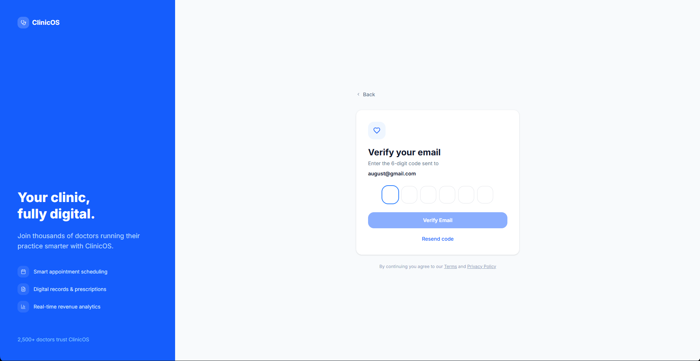
The registration and OTP system creates new user accounts and verifies their email before granting access. It provides:
- New account creation: Users sign up by providing their name, email, password, and selecting their role (doctor or patient) — an optional phone number can also be provided
- Role selection: A toggle lets the user choose between registering as a doctor (to manage a clinic) or as a patient (to access their health portal)
- Duplicate email prevention: If the email is already registered, the user is notified and cannot create a duplicate account
- OTP email verification: After submitting registration details, the user is redirected to an email verification page and a 6-digit OTP code is sent to their email address
- OTP expiry: The verification code expires after 1 hour for security — a new code can be requested if it expires
- OTP input: Six individual digit boxes with auto-focus make entering the code quick and easy, automatically moving to the next box after each digit
- Resend option: If the email doesn't arrive, the user can request a new OTP after a 60-second cooldown
- Post-verification flow: After entering the correct OTP, a success confirmation is shown, the user's account is marked as verified, and they are automatically redirected to the login page to sign in with their credentials
- Data persistence: All user information is saved in the database at the time of registration — verification simply unlocks the account for login
Feature 3: Login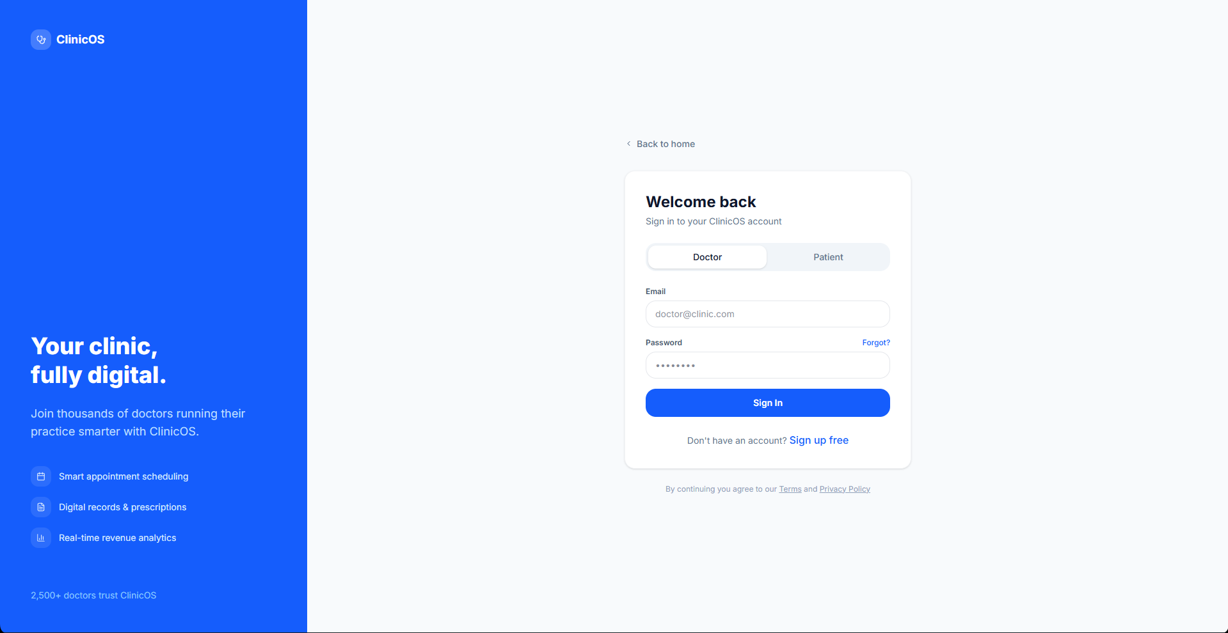
The login system authenticates users and directs them to their appropriate workspace. It provides:
- Role-based redirection: After successful login, the user is automatically sent to their correct dashboard — doctors and assistants go to the main clinic dashboard, patients go to the patient portal, and admins go to the admin panel
- Credential validation: Only users with a correct email and password combination are granted access; invalid credentials return a clear error message
- Email verification gate: Users who have not verified their email via OTP are blocked from logging in and prompted to check their inbox for the verification code
- Session persistence: A JWT token is stored in the browser, keeping the user logged in across page refreshes until they explicitly sign out
- Role-appropriate registration: Registration supports both doctor and patient roles — after registration, a verification OTP is sent to the email, and only after successful OTP verification can the user log in

Feature 6: Doctor Dashboard
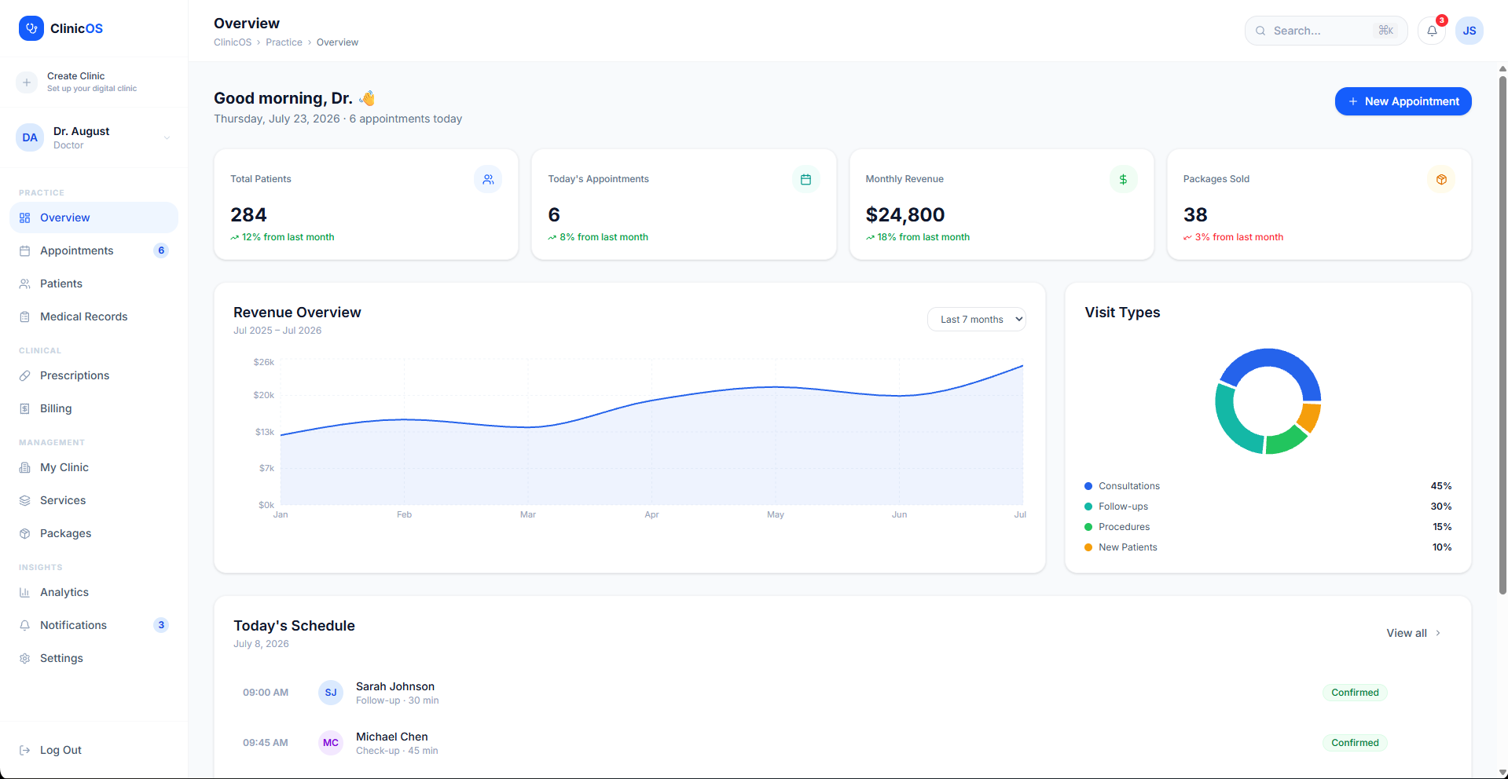
The doctor dashboard is the main workspace for healthcare providers (doctors and assistants). It provides:
- Overview: A homepage showing daily stats — today's appointments, total patients, revenue, and quick charts for monthly trends
- Appointments: View and manage the full appointment calendar (schedule, confirm, complete, cancel, reschedule)
- Patients: Search and browse all patients, view individual patient profiles and history
- EMR (Medical Records): Create, view, and edit electronic medical records for each patient visit — includes diagnosis, symptoms, treatment plan, and follow-up dates
- Prescriptions: Write and manage prescriptions with medication items (name, dosage, frequency, duration, instructions)
- Billing: View invoices, track payments (pending, paid, overdue), and process payments
- Clinic Management: Edit clinic details, manage staff (add/remove doctors and assistants), set operating hours/schedules
- Services: Configure clinic services offered (name, duration, price, availability)
- Packages: Create consultation packages (bundled services at a discounted price)
- Analytics: Revenue reports, appointment statistics, patient demographics
- Notifications: System notifications for appointments, payments, and updates
- Settings: User profile settings, account preferences

Feature 5: Patient Dashboard (User-End)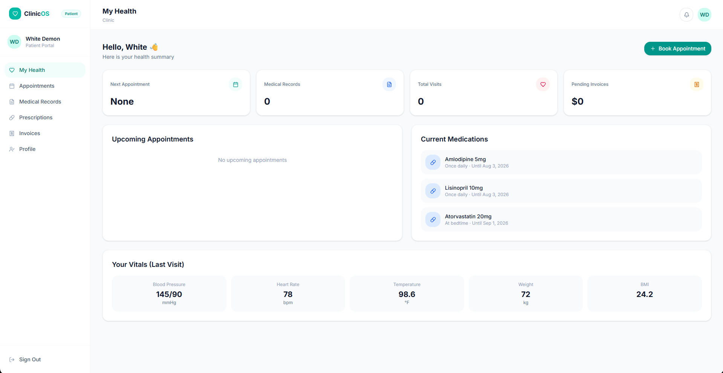
The patient dashboard is the self-service portal for patients to manage their healthcare. It provides:
- My Health (Overview): A summary dashboard showing next appointment, total medical records, visit count, pending invoices, upcoming appointments, current medications, and last visit vitals (blood pressure, heart rate, temperature, weight, BMI)
- Appointments: View all appointments (past and upcoming), book new appointments, reschedule existing ones
- Medical Records: View their complete medical history — diagnoses, symptoms, treatment plans from past visits
- Prescriptions: View current and past prescriptions with medication details (dosage, frequency, duration)
- PlanInvoices: View billing history, see payment status (paid/pending/overdue), pay pending invoices·DeepSeek V4 Flash FreeOpenCode Zen
- Profile: Edit personal information (name, phone), view email and blood type

Sprint 2
Feature 4: Patient Appointment Booking & Scheduling System
The appointment booking system enables patients to schedule online consultations or in-person visits with doctors across available clinic services. It provides:
- Service Selection: Patients browse active clinic services (e.g. General Consultation, Follow-up, Routine Checkup) with transparent duration and pricing information.
- Interactive Date & Time Slot Picker: Patients select their preferred appointment date and time slot from the clinic's active operating schedule.
- Consultation Type & Symptoms: Patients toggle between In-Person and Video Consultation and enter primary symptoms or notes for the attending doctor.
- Real-time Schedule Sync: Booked appointments instantly update the Doctor's daily schedule with Scheduled status and trigger system notification alerts.
[image of the appointment booking modal screen]
[image of the appointment schedule calendar screen]
Feature 7: Electronic Medical Record (EMR) Management & SOAP Notes
The EMR management system allows healthcare providers to document comprehensive clinical patient encounters using standardized medical notes. It provides:
- SOAP Notes Framework: Structured fields for Subjective (patient complaints), Objective (vitals & exam findings), Assessment (diagnosis), and Plan (treatment regimen).
- Clinical History Access: Doctors can review a patient's complete chronological medical record history across all past clinic visits.
- Confidentiality Flagging: Ability to mark specific medical notes as confidential to restrict unauthorized viewing.
- Patient Portal Sync: Finalized non-confidential medical records automatically sync to the Patient Portal for patient access.
[image of the EMR creation and SOAP notes screen]
Feature 8: Digital Prescription Generator with Itemized Medications
The digital prescription engine enables doctors to issue structured electronic prescriptions quickly and accurately. It provides:
- Itemized Medication Table: Dynamic row addition for specifying medicine name, exact dosage (e.g. 5mg), frequency (e.g. twice daily), duration (e.g. 10 days), and administration instructions.
- Diagnosis Linkage: Prescriptions tie directly to the primary diagnosis recorded during the consultation encounter.
- Patient Access & Export: Issued prescriptions immediately populate in the patient's portal with Active/Completed status and downloadable format.
[image of the digital prescription creation modal screen]
Feature 9: Payment Invoicing & Simulated Online Checkout System
The payment and billing module handles fee calculation, invoicing, and simulated digital payment processing. It provides:
- Automated Invoice Generation: Invoices calculate total fees, applicable discounts, and service breakdowns upon appointment booking or completion.
- Payment Status Tracking: Live status tags tracking Pending, Paid, and Overdue invoices for both doctors and patients.
- Simulated Online Checkout: Patients can complete payment using simulated Credit/Debit Card or Mobile Banking (bKash/Nagad) gateways, instantly updating invoice status to Paid.
[image of the invoice payment and checkout modal screen]
Feature 10: Ratings, Reviews & Feedback System
The review system allows verified patients to evaluate clinic services and submit constructive feedback. It provides:
- Star Rating & Written Review: Patients submit 1 to 5 star ratings alongside detailed text feedback following a completed consultation.
- Doctor Dashboard Display: Doctors can view patient reviews and overall average rating metrics directly within their dashboard.
- Admin Moderation Workflow: Platform Administrators review feedback to maintain service quality and handle flagged reviews.
[image of the review submission modal screen]
Feature 11: Doctor-Patient Direct Messaging System
The secure messaging module provides a direct communication bridge between patients and healthcare providers. It provides:
- Direct Message Threads: Patients can send secure messages to their attending doctor regarding follow-up questions or lab results.
- Inbox & Notification Badges: Real-time unread message indicators and organized conversation inbox for doctors and patients.
[image of the direct messaging modal screen]
Feature 12: Platform Administration Panel
The administration panel provides platform super-admins with overarching control across all registered clinics and users. It provides:
- Platform Metrics & MRR Analytics: High-level dashboard monitoring total clinics, active doctors, total patients, and Monthly Recurring Revenue (MRR).
- Clinic Verification & Management: Admin review and approval flow for newly registered clinics, with ability to activate, suspend, or manage clinic status.
- Subscription Tracking: Overview of Starter, Pro, and Enterprise subscription tier distribution across all tenant clinics.
[image of the platform administration panel screen]

